


Executive Summary:
Corbomite Games, a new and innovative independent developer that aims to create brand name entertainment products through downloadable episodic narrative games. The development cost of each game series is estimated at $450,000 for 6 episodes, and an additional $450,000 in marketing costs. Each game series is expected to return $2-3 million dollars on average, and a lot more on a big hit.
We are looking for partnership and investments to expedite the production of our games.

About Corbomite Games:

Using well established game technology, techniques, and art styles, Corbomite will connect comics creators, visual artists, and writers from other mediums to the market of casual gamers and non gamers, developing worldwide successful brand name titles.
Corbomite games are creative, content rich, highly narrative PC games, appealing to the mass audience while concentrating on current untapped identified niches in the game market. At a later stage games will be ported to additional platforms such as consoles, cellular phones and mobile devices. Corbomite Games will create and patent technologies to support the game creation process, but will focus on the games themselves.
All games are produced in an easy to translate manner so it will be easy to penetrate worldwide markets.
Corbomite Games is seeking seed capital to produce its first several games and secure publishing and distribution deals for its games.

Corbomite is currently funded with private investment by shareholders Jeff Pulver and Joseph Sharon, and expecting to become profitable by 2008.

Our games:

Zbang - Corbomite Games' first project is a game based on the most successful Israeli comics. Zbang has been published for the past 20 years, and is still being created and published today. Zbang sold over half a million copies in Israel alone. We are working on the game with the comics creator Uri Fink, and have full copyright and rights to make the game and to all its related merchandise. Zbang is being produced simultaneously both in Hebrew and in English.

Pizza Morgana
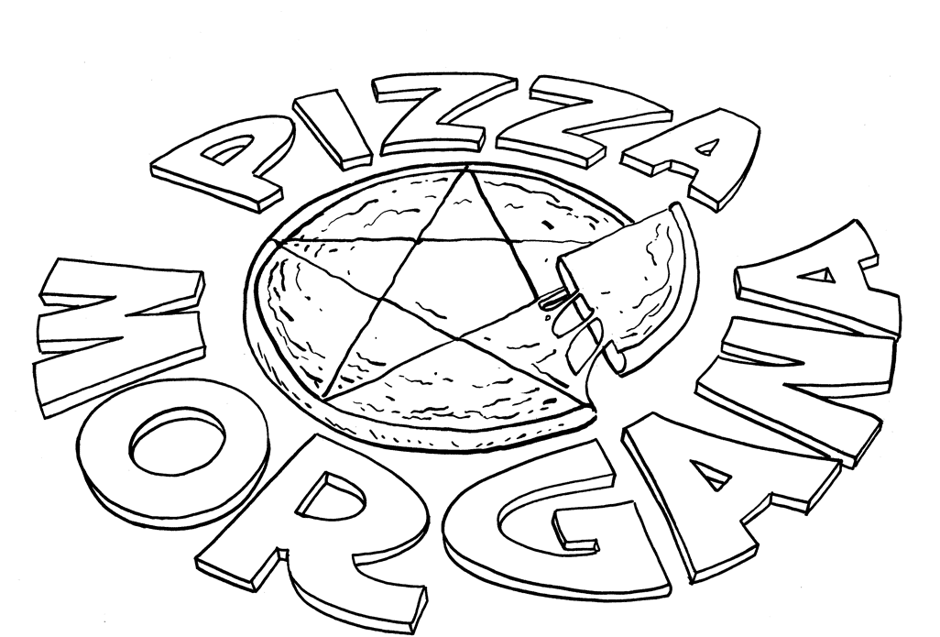
From the same genius comedic mind of Zbang's comics artist Uri Fink comes a charming tale of a young girl who is accidentally teleported into a magical dimension of monsters, vampires, faeries, and daemons, who are all employed as pizza delivery guys, working for the arch wizard (and chef) Morgan!
Pizza Morgana is a young female version in the style of “Harry Potter meets Shrek”.

The Rabbi Stone mysteries
Corbomite games has teamed up with Wadjet Eye Games's Dave Gilbert to produce the sequel (and remake) of the successful hit game “The Shivah”, with new high res graphics, and intriguing storylines. The game is about a New Yorker Rabbi, who is thrust into solving a murder mystery in the Shivah, after one of his old congregation members dies and leaves Stone's synagogue all of his money in his will.

Falafel Man
Based on Israeli comics artist's Dorit Maya-Gur's story about a regular Israeli who is accidentally turned into the super hero Falefel man when he is pushed into a transformation machine that gives him the power to shoot hot oily falafel balls at his enemies. Falafel man fights terrorism, and saves the USA and the world from the next 9/11.

Office Warz
Corbomite games have teamed up with “Bob Productions” to market and produce “Office warz” - a comedic casual game set in the environment of the office cubicle. Your goal is to fight with your co-workers and destroy the office with various weapons made out of regular office supplies like staplers.

A Typical Corbomite game budget and market:

We aim our games to have about 10-12 hours of game play, split into 5-6 episodes with 2 hours of game play each, with each to be sold separately, with an option to subscribe for the entire season. After each game season is complete the season will later be combined and repackaged for retail, to increase revenue.
The expected budget for a period of 10-14 months of game production is $450,000, with a crew of 8-9 developers, and ab additional $450,000 for marketing costs.
Our games are aimed towards the high end of the value games market, where the entire season should be priced at $20 in retail, and each 2 hour episode will be priced for about $5-$10 when sold online, with option to subscribe to a complete season for $20-$30
We estimate that an average game can sell up to 200,000 copies worldwide, and including subscriptions and retail, can produce revenues of up to 4.5 million dollars.

Corbomite has teamed up with multiple game distributions channels such as Gametap, Manifesto Games, Merscom LLC, Telltale Games, and is working with companies like Bigfish, PlayFirst, Eidos, and many others, to distribute it's games with their well established platforms once the games are produced.

The Team:

Oded Sharon, Founder and Acting CEO, is a veteran game programmer and designer with years of experience in making computer games. Oded was involved in game projects like the MMORTS Ballerium, and worked for game publishers in Taiwan, and has successfully managed Corbomite's creative team of developers since 2006.
Oded is also the world Number 1 Zbang fan. He got a signed copy of every Zbang comic that was ever printed.
Oded’s full CV can be found at http://odedsharon.com/cv


Uri Fink, Zbang and Pizza Morgana Art Director, is the legendary creator of Zbang and Pizza Morgana, has been creating comics for 20 years now.
Every since creating the first Israeli super hero at age 15, he created many other comics series like "Super Schlumper", the funniest super hero alive, and "Googi" which documents the life of his two young daughters and their mishaps. Uri brings his humor, unique artstyle, and years of experience in the comics publishing business.

Ilan Weintrob – Art Director
A Veteran designer animator and illustrator, has been creating animations, computer games and TV game shows for the past 13 years, and teaching 3D animation at the WIZO Academy of Design and education and game design at the Bezalel academy of Art and Design. Ilan brings to our projects his vast experience, skill and style.

Dave Gilbert – Lead Game Designer
Creator of the hit game “The Shivah”, and has his own independent game company Wadjet Eye Games which was nominated best game studio in the game developers choice awards in 2007. Dave can offer his vast experience in independent adventure game creation and his many connections in the game industry.

Oded Saar – Game Designer
A young and aspiring game designer with a lot of talent who brings his experience as a technical writer in the Israeli high-tech industry to write and perfect game design documents.

Lior Nasichi – Game Programmer
A brilliant, eager and experienced programmer who is leaving his well paid, but boring job in the grey high tech corporate programming world, to join Corbomite. Lior holds a BSC in Math and Computer Sceince from Tel-aviv University.


Reut Almog, Game Writer, is the co-editor of the monthly Zbang magazine, and even appears in it, only with a bigger cleavage.
When she's not visiting Uri's studio or too busy writing the Zbang diary for 2007, she's an editor of a magazine about yachts. She's holds a master's degree in literature, and is working hard on a script for an Israeli fantasy film.

Yael Luxman – Lead Creative Designer
Chief editor and writer for many books and publications with over 10 years of experience. Yael offers a wide knowledge in a variety of story telling mechanism with her experience in role playing games, and her leading role in the Israeli role playing community.

Phil Morris – English Supervisor and audio
Varied creative and business management background mostly in the UK computer games industry, from developing and publishing computer games at English Software Company in Manchester in the 1980s through to producing music, audio and speech in the 1990s in Liverpool for Sony Psygnosis, and then speech for AllintheGame Ltd up to 2006.

Ido Shalom, 3D artist– A young and talented 3D artist who brings the Zbang characters to life through 3D work. Ido worked on creating models and textures for various FPS mod titles, and is also working for the Israeli Army graphics department.

Ilya Dorman – 3d artist
Ilya is a student of 3D and recently joined the team to create and animate the various characters in Corbomite games.


More About Zbang:
Zbang, is the most famous, recognized, and sold comics series in Israel for over 19 years now.
With nearly six hundred thousand copies sold, Zbang is still being produced, and published in many forms, among which weekly 3-page comic strip in Maariv Lanoar (A weekly youth magazine), and a 40 page monthly magazine. Zbang keeps the active imagination of Israeli teenagers, well... active.

In the late 90's Zbang was adapted into an Israeli television series with many known names in Israeli entrainment like Yossi Graber, Sandy Bar and others. Since then the show has been syndicated, and now it's aired in Israel again.

Zbang readership and subscribers:
The Zbang magazine has 2,000 subscribers and a readership of 5,000.Zbang is published in Maariv Lanoar which is published weekly, and has about 15,000 subscribers and a readership of 100,000.
Nearly 600,000 copies of Zbang, in its various forms, were sold over its 19 years of existence. This includes hardcover 120-200 page A4 books, comic booklets, school diaries, and more.


About Zbang! the game:
"Zbang! The Game" is a comedy game where you play multiple characters, like Mike, an average teenager, who likes to surf, play rock'n'roll, and fantasize about having sex with his girlfriend, Jennifer. Later on you'll play Jennifer, and other Zbang characters, and enjoy a wide variety of story development routes. In the game you get to meet Mike, Jennifer, and his gang of friends and foes, and in the center of it all, lies Mike and Jennifer’s love story.
There’s nothing more basic than a romantic comedy. There are many great love stories throughout the history of man kind. There were many couples you might remember: Romeo and Juliet, Ross and Rachel, Pam and Michael. Will Mike and Jennifer’s story be written down in history as the worlds’ greatest love story of all times? You’ll be the one calling the shots through your game play.

Websites:
Corbomite Games Website http://corbomitegames.com/

Zbang! - the game's website :
Hebrew - http://corbomitegames.com/zbeng
English - http://corbomitegames.com/zbang

Pizza Morgana – http://pizza-morgana.com

For more into please contact us, we’ll be happy to answer any question:
business@corbomitegames.com

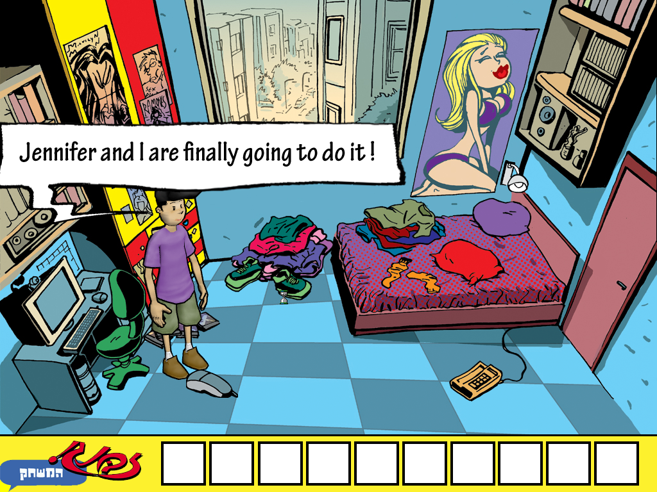
Actual screenshot from the Zbang demo game: Mike is sure that he’s going to sleep with Jennifer tonight, but will he?
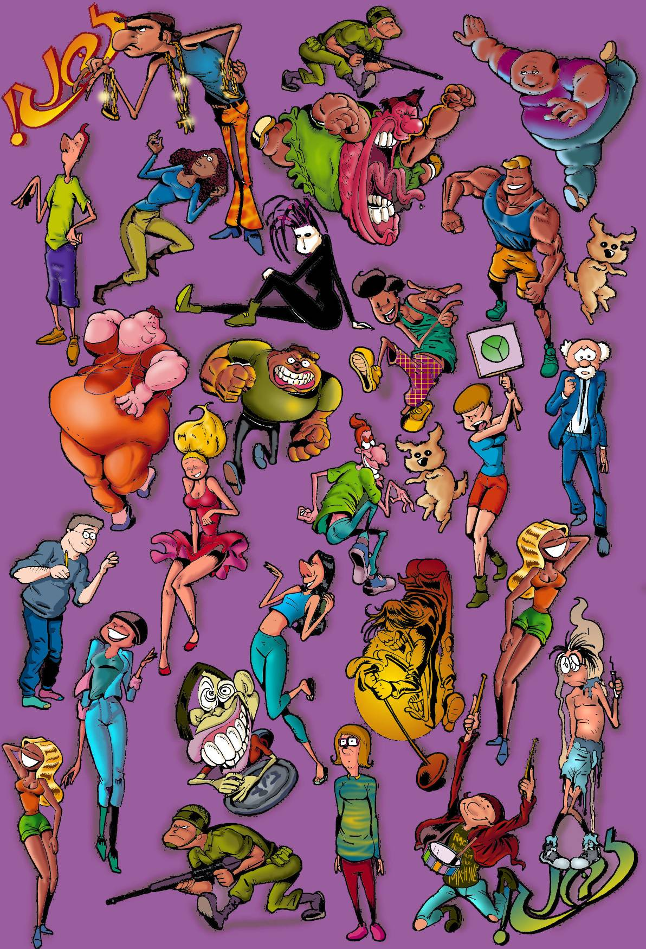A collection of Zbang Characters
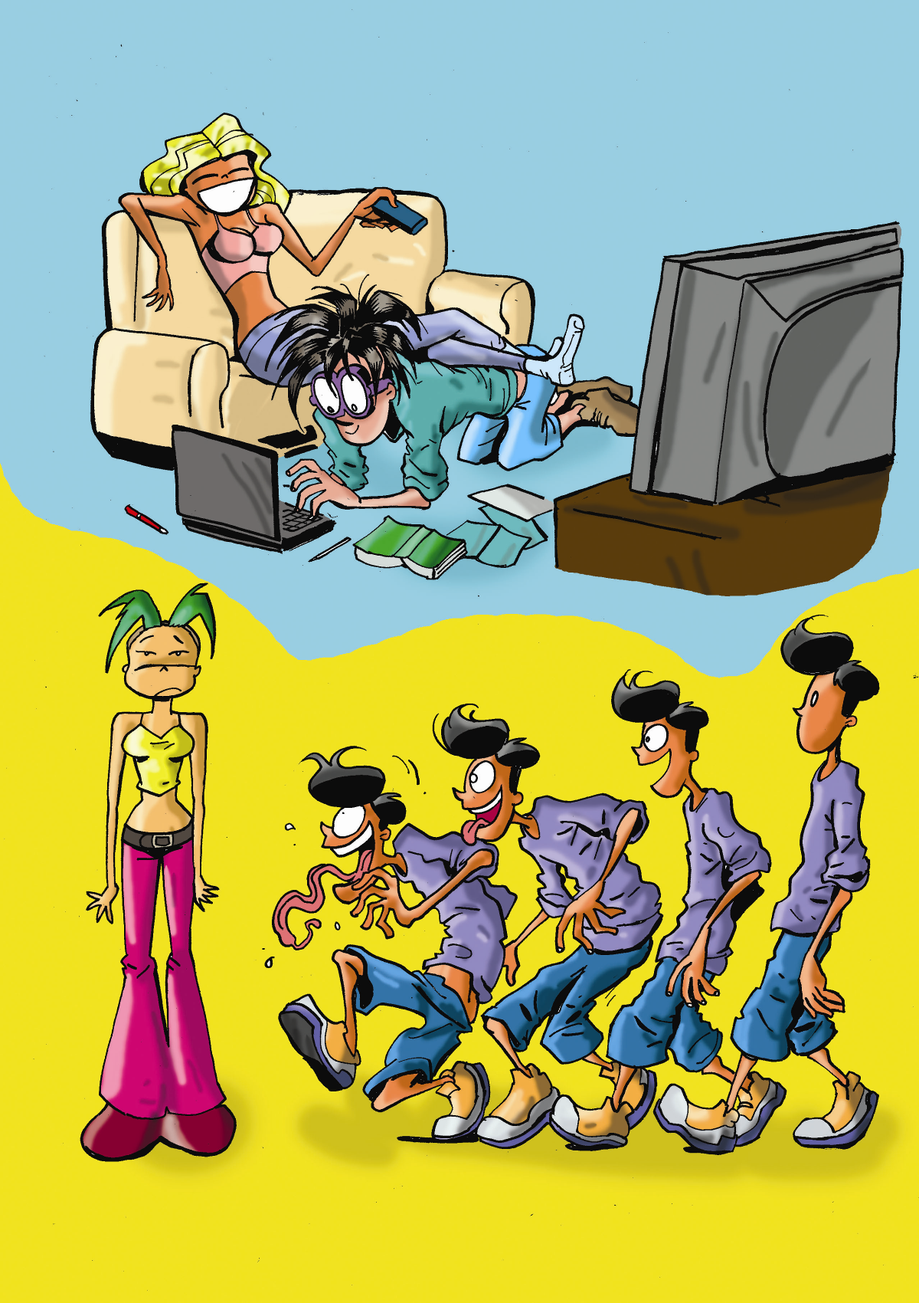
Example illustration: Evolution of modern man

